**Reference points for 6a, 7bc herring**

**Martin Pastoors1**

16/03/2019 18:28

[ All the codes to generate this section of the report are in *refpts her6a7bc.Rmd* on the wgHAWG github page]

Biological reference points using the development version of ICES MSY package (v.0.1.18) and EQSIM method, applied to the final assessment of the Interbenchmark 2019. The new assessment provides a very different perception of stock trends and the stock recruitment relationship compared to the most recent accepted assessment (HAWG 2018), notably because the most recent years have now been estimated to have been with low SSB and low recruitment, whereas before the low recruitments where thought to be with higher SSB.

Because the final assessment is a multifleet assessment, the methode *collapseFleets* has been applied to collapse the multifleet object into a single fleet object that can be used in EQSIM.

The reference points as estimated in WKWEST 2015, and used by ACOM since then, are as follows

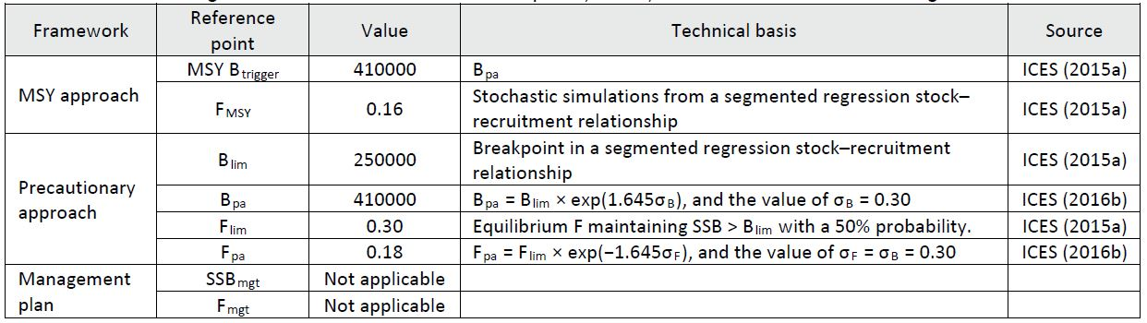

The stock trends of the IBP assessment show that the recruitment and stock have been very high in the period 1960-1970. At the same time there is substantial uncertainty about the data for the period. Given that these high SSB-high recruitment period has a large impact on the estimated stock and recruitment pairs, two separate analysis have been carried out: one using the whole time-series and one using a time-series from 1975 onwards.

A comparison between the IBPHER6a7bc assessment results (green dashed lines) and the previous assessments of this stock are in the figure below.



This change in perception of SSB and recruitment had a profound effect on the breakpoints estimated by the segmented regression analysis. Below is the segmented regression from the IBP final assessment using the whole time series. The estimated breakpoints in the IBP assessment have experienced a strong shift to the right (i.e. at higher SSB).

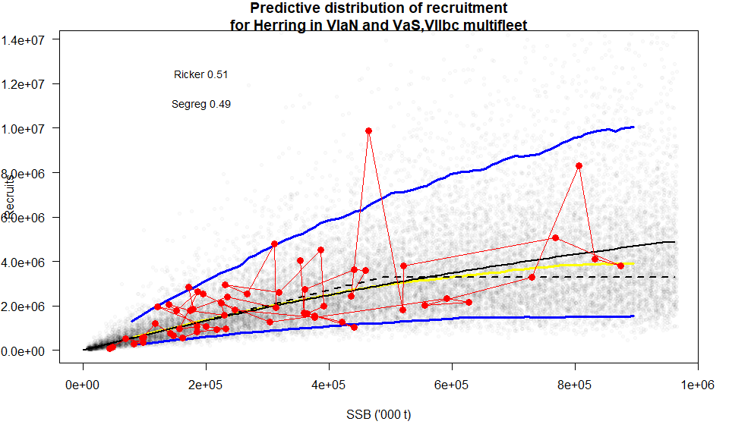

Settings used for the EQSIM analysis. Fcv and Fphi were derived from *HER 6a7bc Fcv and phi.xlsx*.

---------------------- -----------  
**nsamp** 2000   
**bio.years** 2008-2017   
**bio.const** FALSE   
**sel.years** 2008-2017   
**sel.const** FALSE   
**recruitment.trim** 3--3   
**Fcv** 0.3   
**Fphi** 0.37   
**verbose** FALSE   
**extreme.trim** 0.01-0.99   
**Nrun** 200   
**rshift** 1   
---------------------- -----------

Following the standard procedure for estimating reference points, Blim was estimated at 490 000 tonnes. Using that as a starting point for generating the other reference points resulted in several reference points that could not be estimated (notably Fp05, MSY Btrigger) because of lack of convergence. This is probably due to the current low stock size and the high Blim.

Given that the historical dynamics of the stock has not changed substantially with the interbenchmark of these stocks, it was decided to keep the previously estimated Blim (250 000 tonnes) as the basis for generating the other reference points. An overview of the calculated reference points is in the text table below.

Flim Fpa Fmsy Fp05 Blim Bpa MSYBtrigger  
1 0.14 0.11 0.08 0.11 250000 330000 650000

Shortening the time series to 1975 made significant differences to the reference points so they are highly dependent on the length of the time series. However, in this case, again, not all the reference points could be estimated.

[1] "Warning: Fp05 not defined"

Flim Fpa Fmsy Fp05 Blim Bpa MSYBtrigger  
1 0.11 0.09 0.09 NA 250000 330000 450000

**Conclusion**

HAWG has received the analyses and conclusions from IBPHER6a7bc and concluded that progress has been made with this assessment, although it is also acknowledged that a full benchmark will be carried out within a few years which will, hopefully, be able to split the two stocks into separate assessments. Given the new perception on the productivity of the combined stocks, it was still considered relevant to update the reference points after the IBPHER6a7bc. The timeseries of stock and recruitment is now such, that it was not possible to estimate reference points using the standard methodology. The reason was that the breakpoint in the stock recruitment relationship was too far to the right to be able to generate a meaningfull MSY Btrigger or Fp05. Instead, HAWG took the previously agreed Blim as the basis for calculating reference points. This resulted in a Fmsy of 0.09 reflecting the lower productivity of the stock as suggested by the assessment that was agreed at IBPHER6a7bc.